Growth Equity Interview Guide for Undergrads
Meta description: WSG founder Stephen Turban breaks down the growth equity interview for undergrads: sourcing questions, SaaS metrics, deal terms, a worked screen and answers.

Growth equity interviews test whether you can find and judge companies before they test whether you can model them. Most undergrads prep in the opposite order. They buy a modeling course, memorize the accounting questions, rehearse the LBO walkthrough, and then the first real question on the phone is "pitch me a company we should look at this week." Silence. The growth equity interview is built around that question because the analyst job is built around it. Insight Partners' own posting for its sourcing analysts says "without you, our deal pipeline does not exist" [VERIFY: wording on Insight's Investment Summer Analyst program page, info.insightpartners.com]. The model shows up later in the process, and it's simpler than the one you built for banking.

I'm Stephen Turban. I run WallStreetGuide, and every fall I watch a few juniors land growth equity analyst and summer analyst seats at firms most of their classmates can't name. The ones who get there didn't out-model the field. They walked in with three companies they'd already found, a reason for each one, and a clear answer to "what would make you pass."

This guide covers what growth equity is against venture and buyout, which firms hire undergrads and when, what the analyst does all day, the interview round by round, every question type with a full sample answer, a worked investment screen with the arithmetic shown, a sourcing drill you can run this week, and a four-week plan.

What do growth equity interviews ask?
Three things, roughly in this order of weight. First, whether you can find companies: how you'd build a list in a vertical, a pitch of a company you've already found, what you do when a founder ignores you. Second, whether you can judge them: software metrics like net revenue retention and CAC payback, a short case on a company's deck, and the "what would make you pass" questions. Third, whether you can do the arithmetic: a growth model, a cap table, a returns calculation that includes a liquidation preference. Growth equity interviews weight sourcing and judgment above modeling, which is the reverse of a banking interview. Behavioral questions run through every round, and the final with partners is mostly judgment and fit.

Do growth equity firms hire undergrads?
Yes, and more of them do than buyout firms. General Atlantic, Insight Partners, JMI Equity, Silversmith, Volition and Five Elms all post analyst roles for graduating seniors, and Insight, Spectrum Equity, Summit Partners, PSG, Volition, Five Elms and Vista run summer programs for juniors [VERIFY: each firm's current posting; the detail is in section 2]. Growth equity is the most realistic direct path from undergrad into an investing seat, because the analyst's main job, sourcing, is one a 22-year-old can do well. Section 2 has the list with timing. If you're weighing this against the buyout route, our guide to landing a private equity internship as an undergrad covers the other side.

1. Growth equity buys a minority of a company that already works
Start with the company, because everything else follows from it. A growth equity target has real revenue, usually tens of millions of dollars a year, and is growing fast, often 25 percent a year or more. It is profitable or close to it. It doesn't need the money to survive; it wants the money to go faster, buy a competitor, or let an early investor or a founder sell some shares. The example company I'll use through this article, a fictional software business called Harborline that sells dispatch and billing software to freight brokers, has $60.0 million of annual recurring revenue, grew 50 percent last year, and burned $5.0 million of cash doing it. That's the shape.

Growth equity is a minority stake in a company that already has real revenue and real growth, bought without debt, with a preferred share that protects the downside. Take the three pieces of that sentence one at a time.

Minority stake. A growth investor usually buys somewhere between 10 and 40 percent of the company [VERIFY: typical range; firm sites describe "minority or majority"]. The founder keeps control. In the Harborline deal in section 11, the firm puts in $100.0 million and ends up with 16.67 percent. Compare that with a buyout, where the firm buys most or all of the equity and can replace the CEO. Compare it with venture, where a Series A investor might also own 20 percent, but of a company that hasn't yet proved the product sells.

Without debt. A buyout firm pays for a big share of the purchase with borrowed money, and the company carries that loan afterward. The returns come from paying the loan down with the company's cash flow and from widening margins. Growth equity deals are usually all equity: the firm writes a check, the company issues new shares, and no bank is involved. The money typically goes onto the company's balance sheet (a "primary" investment) to fund hiring and sales, or to existing shareholders who want to sell (a "secondary"), or some of each. If you want the buyout mechanics side by side, our LBO walkthrough shows where those returns come from.

A preferred share with downside protection. The growth investor doesn't buy the same common stock the founder holds. It buys preferred stock, a separate class of shares with extra rights. The right that matters most is the liquidation preference: when the company is sold, the preferred holder gets its money back before the common holders get anything. Section 9 walks that with numbers. The short version: if Harborline is sold for less than the firm hoped, the preference means the firm still gets its $100.0 million back first. If Harborline is sold for a lot, the firm converts to common and takes its 16.67 percent. Preferred stock is how a growth investor accepts a minority position without accepting a minority investor's risk.

Now the two neighbors.

Venture pays for the chance that a product works; growth equity pays for proof that it already does. A seed or Series A investor is betting on a team and an idea. Most of those bets lose money, and one big winner is supposed to pay for the rest. A growth investor can see three years of revenue, a list of customers, how many of them renewed, and how much it costs to win a new one. The price is higher because the risk is lower. The return target is lower too: a growth fund underwriting a deal (building its own case for what the deal should earn) to a 3x return and a 25 percent IRR (internal rate of return, the yearly return the deal earns) is normal, where a venture fund needs some positions to return 20x or more to make the math work [VERIFY: typical growth equity underwriting targets; firm-specific].

Buyout returns come from debt and margin; growth equity returns come from the revenue line. In an LBO, a company growing 5 percent a year can produce a 20 percent return for the fund if it pays down enough debt and expands margins. In growth equity, with no debt and usually no margin to expand yet, the only way to make 3x is for revenue to roughly triple and for the exit multiple to hold. That one sentence explains why every growth equity interview question comes back to growth, retention, and the cost of growth. There's no other lever.

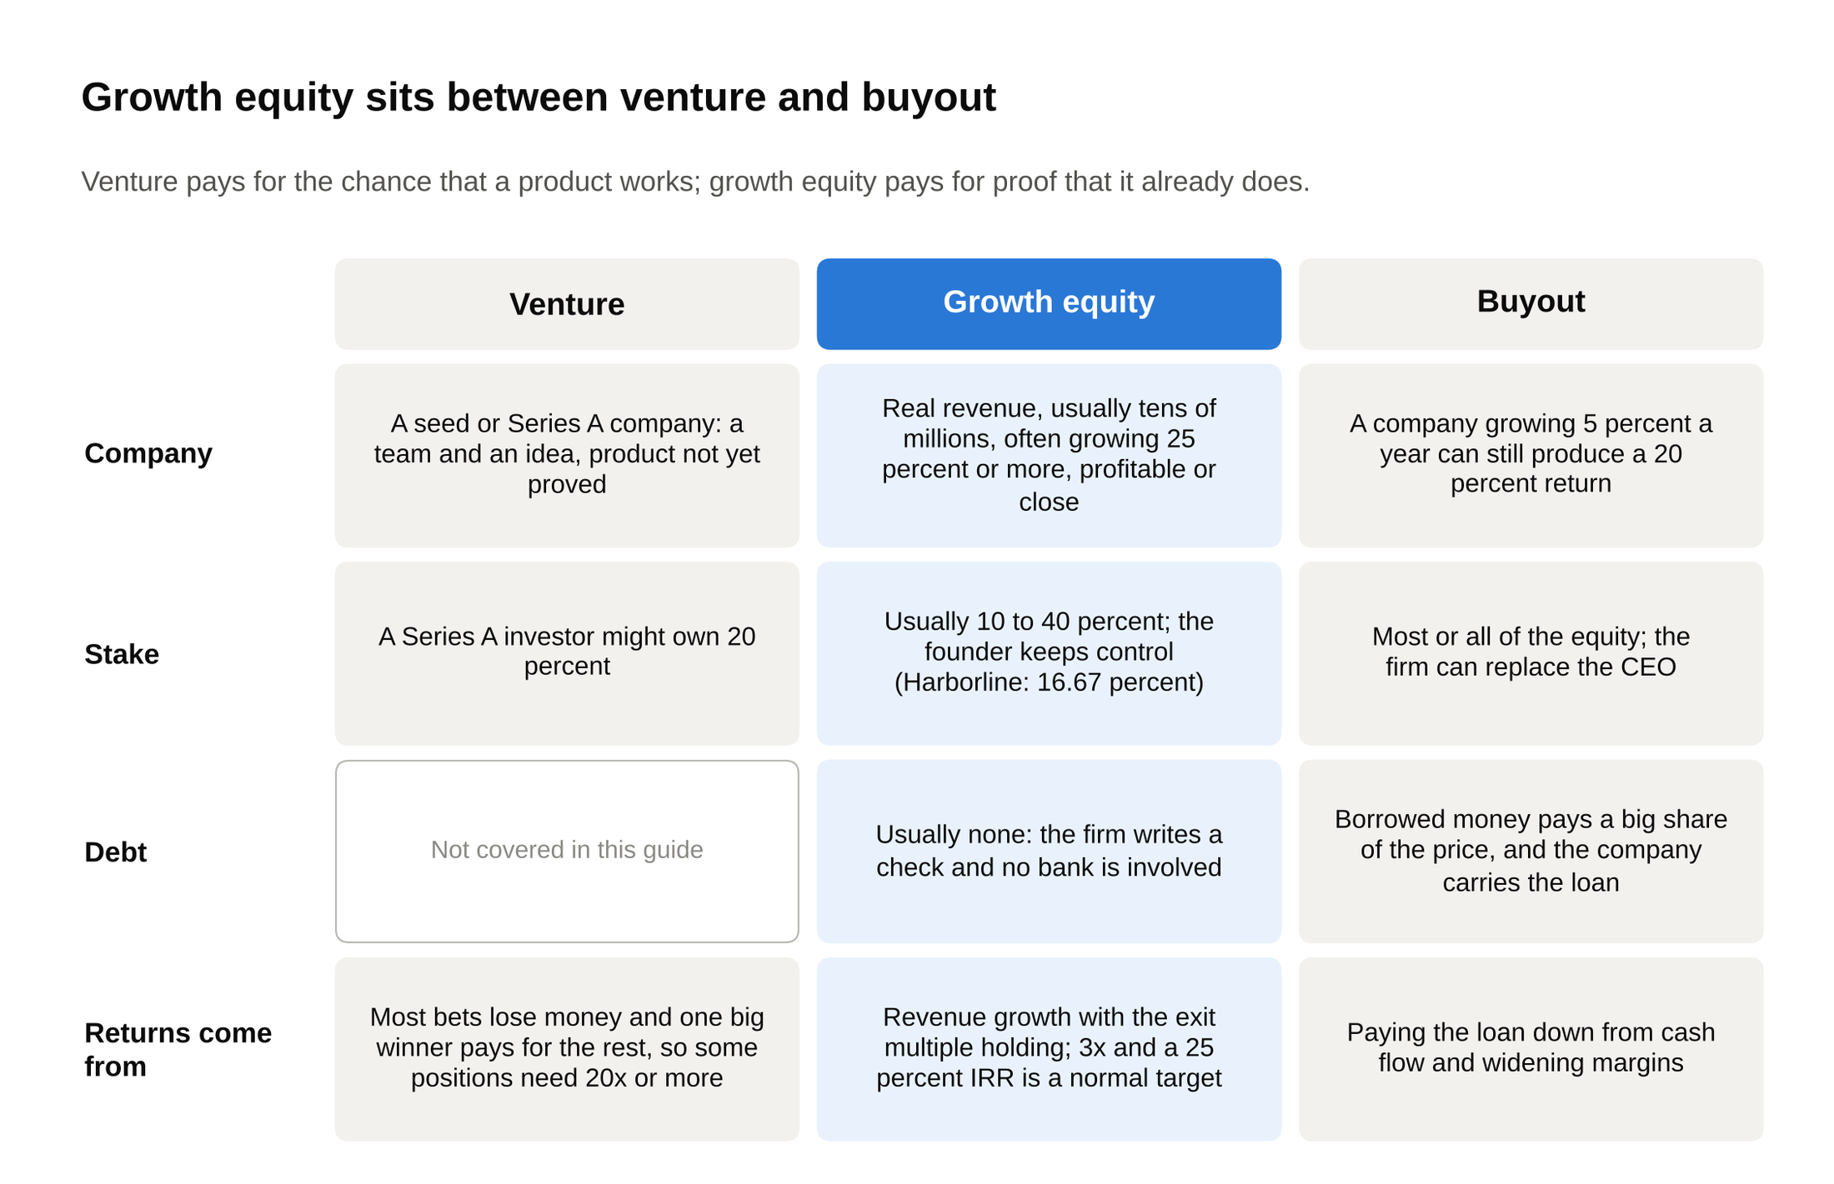
Read across the Debt row: buyout borrows to pay the price, growth equity usually writes an all-equity check, so the only lever left is the revenue line.

One more framing that helps in interviews. General Atlantic describes itself as having pioneered the growth equity strategy, and its founding story is the cleanest illustration of what the category is for. Chuck Feeney, who co-founded Duty Free Shoppers, set up GA in the spring of 1980 as a direct investment vehicle and was its only investor for more than a decade [VERIFY: generalatlantic.com/about-us]. The point of the firm was to back businesses that were already working and compound the money, and Feeney then gave the compounded money away: Atlantic Philanthropies distributed more than $8 billion in grants and dissolved in 2020, and he died in October 2023 at 92 [VERIFY: atlanticphilanthropies.org]. Growth equity started as patient money for companies that didn't need rescuing.

2. The firms that hire undergrads, and what each program looks like
Every program below was checked on the firm's own site or its own job board in October 2026. Firms you may have heard of in growth equity that aren't on this list (Stripes, Level Equity, Great Hill, TCV, Lead Edge, Mainsail, Battery, Sageview, Warburg Pincus) didn't publish an undergrad program I could confirm, which usually means the junior seats are filled from banking or from other funds, or that hiring is one-off. Treat them that way until you see a posting.

Growth equity hires in two lanes: a summer analyst seat for juniors and a full-time analyst seat for seniors, and most firms run both. The table is the short version; the notes under it have the detail and the tags.

Firm | Founded | Full-time analyst from undergrad | Summer program for juniors | Where | Next cycle to watch
General Atlantic | 1980 | Yes (Analyst Program, about two years) | Yes (Summer Growth Experience) | New York plus 20 other offices | Fall and spring openings [VERIFY]
Insight Partners | 1995 | Yes (Full Time Investment Analyst) | Yes (Summer Investment Analyst) | New York | Fall opening, May close [VERIFY]
TA Associates | 1968 | Associate Program (details unpublished) | Not posted | Boston, Menlo Park, Austin | Rolling, by email [VERIFY]
Summit Partners | 1984 | Associate now asks for 2 to 3 years of experience | Yes (10-week Summer Internship) | Boston, Menlo Park | Winter close [VERIFY]
Spectrum Equity | n/a | Not posted | Yes (Summer Analyst, 10 weeks) | Boston, San Francisco | October 21 close for Summer 2027 [VERIFY]
JMI Equity | 1992 | Yes (2027 Analyst) | Not posted | San Diego, Washington, Baltimore | Rolling [VERIFY]
PSG | 2014 | Not posted | Yes (Summer Internship) | Boston, Kansas City, London | 2027 closed; 2028 unposted [VERIFY]
Silversmith Capital Partners | n/a | Yes (Analyst, September 2027 start) | Not posted | Boston | Open on HireVue [VERIFY]
Volition Capital | n/a | Yes (Analyst) | Yes (rising seniors) | Boston | Rolling [VERIFY]
Five Elms Capital | n/a | Yes (new graduate analyst) | Yes (summer analyst) | Kansas City | Rolling [VERIFY]
Vista Equity Partners | 2000 [VERIFY] | Via the summer program | Yes (Summer Analyst, 10 weeks) | Chicago (summer); Austin, San Francisco | January close [VERIFY]
Susquehanna Growth Equity | 2006 | Not posted | Interns mentioned on its jobs page | Bala Cynwyd, Pennsylvania | See sig.com/careers [VERIFY]

Now the notes; the founding years in the table are tagged where they appear below. For a junior reading this in October 2026, the summer seats are for Summer 2027, and some of those windows have already closed; for a sophomore, the Summer 2028 cycle opens next fall and runs on the same pattern.

General Atlantic. GA runs an Analyst Program for US and UK undergraduates, "generally two years," and analysts "evaluate companies across early stage, late stage, leveraged buyouts, publics, and support portfolio initiatives" [VERIFY: generalatlantic.com/careers/early-careers]. Its summer internship is the Summer Growth Experience, and the page says applications "generally open in the fall and spring" [VERIFY: same page]. GA lists about $130 billion of assets under management and 21 offices [VERIFY: generalatlantic.com, August 2026]. It's the largest firm on this list by a wide margin, and its analysts see a broader mix of deals than a pure sourcing shop.

Insight Partners. Insight's full-time Investment Analyst posting for the 2027 class took undergraduates "graduating between December 2026 and June 2027," starts in September 2027 in New York, and lists a $125,000 salary [VERIFY: Insight 2027 Full Time Investment Analyst posting; the listing closed]. The Summer Investment Analyst program for Summer 2027 took juniors graduating between December 2027 and June 2028, started in early June 2027, and paid at a $110,000 annual rate pro rated for the summer; applications closed on Friday, May 22 [VERIFY: Insight 2027 Summer Investment Analyst posting and the program page, whose dates and graduation range don't match each other; confirm the Summer 2028 window on Insight's campus recruiting portal]. The posting language matters more than the pay: "you will be speaking with entrepreneurs every day," and sourcing "is not easy work" [VERIFY: posting text]. Insight was founded in 1995 by Jeff Horing and Jerry Murdock [VERIFY: Wikipedia; Insight's site says "over 30 years"] and says it has backed more than 800 companies.

TA Associates. TA's careers page names an Associate Program and gives a talent contact for it, but doesn't publish who it takes or when [VERIFY: whether TA's current Associate class takes undergraduates directly or only post-banking hires; ta.com/careers]. TA is the oldest firm here. It was founded in Boston in 1968 as an affiliate of the brokerage Tucker, Anthony & R.L. Day and became a separate partnership in 1978 [VERIFY: ta.com/about]; its site cites $65 billion of capital raised as of 2023 and more than 500 investments [VERIFY: same page]. If you want TA, email the contact on the careers page in the fall of your junior year and ask directly.

Summit Partners. Summit's Summer Internship on the Investment Team is a paid, roughly 10-week program in Boston or Menlo Park; the Summer 2026 posting took only 2027 graduates and set a 3.6 GPA floor [VERIFY: Summit Greenhouse posting; the deadline shown was February 28]. Its full-time Associate (2027) posting asks for "two-to-three years of professional, quantitatively-based experience," requires a three-year commitment, and lists a $150,000 to $160,000 base [VERIFY: job-boards.greenhouse.io/summitpartnerslp]. So Summit is a summer-only lane from undergrad right now, with the full-time seat coming after banking. Summit was founded in 1984 and reports more than $44 billion under management and 550 or more portfolio companies [VERIFY: summitpartners.com/about-us].

Spectrum Equity. Spectrum's Summer 2027 Growth Private Equity Summer Analyst role is for 2028 graduates, runs up to 10 weeks in San Francisco or Boston, pays a monthly stipend of $6,500 to $8,500, and the application (a resume plus recorded video questions through Spark Hire) is due October 21, 2026 [VERIFY: posting on Harvard's career services board, Spectrum's own text]. The posted duties are the job in one line: "Sourcing new investment opportunities," "Researching potential investment themes," and "Assisting in due diligence" [VERIFY: same posting]. If you're a sophomore, expect the same window in October 2027.

JMI Equity. JMI's 2027 Analyst posting takes candidates with "0 to 2 years of full-time work experience," starts July 30, 2027, is based in San Diego (the firm also has offices in Washington and Baltimore), and pays a $100,000 base plus a discretionary bonus plus "deal bonuses for investments sourced by Analysts" [VERIFY: jobs.lever.co/jmi]. Read that last clause twice; it's the clearest statement on any posting of what the analyst is for. JMI was founded in 1992 and invests in software [VERIFY: same posting].

PSG. PSG's careers page says its 2027 Summer Internship applications are closed [VERIFY: psgequity.com/careers, October 2026]. The firm was founded in 2014, invests in growth-stage software, and has described its offices as Boston, Kansas City and London [VERIFY: a 2022 PSG posting; confirm current offices]. Watch the Workday portal linked from its careers page for the 2028 posting.

Silversmith Capital Partners. Silversmith lists an Analyst role in Boston starting September 2027, applied for through HireVue; the role is "researching companies and actively interacting with founders & CEOs, assisting with quantitative and qualitative due diligence, and working with management teams post-investment" [VERIFY: silversmith.com/careers; the page's eligibility line still reads "graduating between May and December 2024," so confirm the class year with the firm]. Silversmith invests in technology and healthcare companies out of Boston.

Volition Capital. Volition posts an Analyst role and a summer internship for "rising seniors to spend their summer in Boston," and its analyst page says analysts "conduct outreach and travel to meet founders" and are "paired 1 on 1 with a VP or above with weekly meetings" [VERIFY: volitioncapital.com/careers-analyst and careers-intern]. The firm backs "founder-owned, capital-efficient businesses," writes checks of $5 million to $50 million, and closed its sixth fund at $950 million [VERIFY: volitioncapital.com/company]. Volition is the purest sourcing shop on this list: founder-owned companies with no prior investors are, by definition, companies nobody else has found yet.

Five Elms Capital. Five Elms runs "summer analyst and full-time new graduate analyst programs" across its Investment, Operations and Sourcing teams, out of Kansas City [VERIFY: fiveelms.com/careers]. It invests in B2B software, reports more than $3 billion under management, and closed its sixth fund at $1.1 billion in 2024 [VERIFY: fiveelms.com].

Vista Equity Partners. Vista is a buyout firm first, but its Summer Analyst program is one of the most structured undergrad seats in software investing and belongs here. The 2027 program was 10 weeks, exclusively in Chicago, for students graduating between winter 2027 and spring 2028, paid at a $100,000 to $110,000 annual rate, with a January 19, 2026 deadline [VERIFY: Vista 2027 Private Equity Summer Analyst posting]. Full-time analysts sit in Chicago, Austin or San Francisco. Vista's growth-stage strategy is Endeavor, which "invests in small-cap businesses seeking a partner for growth" [VERIFY: vistaequitypartners.com/private-equity], and the firm reported $103 billion under management as of June 30, 2026 [VERIFY: vistaequitypartners.com].

Susquehanna Growth Equity. SGE, founded in 2006 and part of Susquehanna International Group, says on its jobs page that "whether you're an intern or a senior professional, you'll be actively involved in the investment process from day one," with openings posted on sig.com/careers [VERIFY: sgep.com and sig.com/sgejobs]. It doesn't describe a formal program; check the postings in the fall.

The deadlines don't cluster the way banking's do, so you track each firm on its own calendar. Spectrum closes in October, Vista in January, Summit around February, Insight runs to May, and GA and JMI are rolling [VERIFY: each]. A junior who starts looking in January has already missed one of the best seats. Two more things the table can't show. Growth equity firms mostly hire directly, through their own portals and campus visits, rather than through headhunters; the headhunter funnel described in our guide to private equity recruiting firms matters later, for the post-banking associate seats. And the smaller firms on this list (Silversmith, Volition, Five Elms, JMI) hire in small numbers, sometimes one or two analysts a year, so a single strong referral carries more weight than it would at a bank.

3. The analyst job is sourcing, and the interview is built around it
Here's a week in the life, assembled from the firms' own postings and from the analysts I've talked to.

Sourcing is the job at the analyst level: you find private companies, get the founder on the phone, and decide in fifteen minutes whether the firm should spend a partner's time on it. The pipeline starts with a list. The analyst picks or is assigned a vertical (say, software for physical therapy clinics), builds a list of every company selling into it, and ranks them. Then the outreach: cold emails, LinkedIn messages, and calls to founders and CEOs, usually dozens a week, each one logged in the firm's CRM (a customer relationship management database; Salesforce is the one most people know) so the whole firm can see who has talked to whom. Most sourcing programs set a weekly target for new companies logged and founders reached; the number varies by firm, and it's a fair question to ask in your interview.

A founder who takes the call gets a first screen. That's a 20 to 30 minute conversation with ten to fifteen questions: what the product does and who buys it, how much revenue, how fast it's growing, how many customers renewed last year, how the company is funded and who owns it, whether the founder would ever take outside money and for what. The analyst writes it up in a page. Most companies get a polite "let's stay in touch" and a reminder in the CRM to call back in six months. A few get passed up to a vice president, and a handful of those a year become live deals.

Between calls, the analyst builds market maps. A market map is a one-page picture of a vertical: every company in it, grouped by what they sell and who they sell to, with a line on size and ownership. It's the firm's institutional memory of a space, and it's how a partner decides whether a vertical is worth a theme. Once a company goes live, the analyst joins the deal team: pulling the data room, building the model (section 11 is a simplified version), calling customers, and drafting pieces of the investment memo.

Why does sourcing sit with the most junior person? Because the thing a growth equity firm is competing on is seeing the right company before anyone else does. There are tens of thousands of private software companies in the United States, and the good ones that haven't taken institutional money don't advertise. The firm that calls a founder-owned company growing 40 percent a year two years before it hires a banker gets a relationship and often a price nobody else was offered. A 22-year-old can do that work as well as a 35-year-old, and in some ways better: it takes hours, persistence, and the willingness to hear no fifty times a week, and it doesn't require having closed a deal before.

The interview asks you to do the job in the room, because a firm can teach you Excel in a month and can't teach you to find companies on your own. That's why "pitch me a company" shows up in the phone screen, again in the sourcing round, and often again in the final with a partner who read your first answer in the notes. And it's why the deal bonus matters. JMI's analyst posting pays a bonus on investments sourced by analysts, which tells you exactly how the firm values the work. [VERIFY: jobs.lever.co/jmi]

A student I worked with through WSG last fall, call him Rohan, learned this the expensive way. Before he found us he'd had a growth equity phone screen in which he answered "why growth equity" well and then had nothing when the analyst asked which companies he'd been looking at. He came to WSG a week after the rejection email. We picked a vertical he already knew (software for independent veterinary clinics; his parents run one), he built a list of thirty companies over a few weekends, reached a handful of founders, and wrote one page on each of the three he liked. In his next process, a partner in the final round asked about one of those companies by name, because the analyst from his first screen had put it in the notes. He got the summer analyst offer. The model test in that process was a cap table and a three-year ARR build. It took him under an hour.

4. The growth equity interview process, step by step
The order below is typical. Firms skip steps or merge them, and the smaller firms move faster.

Resume screen. The screener is looking for evidence that you have found things on your own: a startup internship, a student venture fund, a sales job, a research project you started, a cold outreach story. Banking internships help but don't decide it. A 3.6 or better GPA is a hard filter at some firms; Summit's summer posting states it [VERIFY: Summit Greenhouse posting].

Video or phone screen. Twenty to thirty minutes with an analyst or associate, or recorded video questions (Spectrum uses Spark Hire; Silversmith uses HireVue [VERIFY: each firm's posting]). Why growth equity, why this firm, walk me through your resume, and one company you'd want the firm to look at. Video screens are common at the smaller firms, and they test the same thing the phone screen does: whether you have a company ready.

The sourcing conversation. Thirty to forty-five minutes with an associate or a vice president. "How would you find companies in X." "Here's a vertical we like; what would you want to know about a company in it." "Pitch me a company." "What do you do when the founder won't take the call." Section 6 has sample answers.

The case. You get a short deck or a few pages from a data room (the folder of financial and legal documents a company opens to a potential investor) on a real or disguised company, sometimes an hour before the conversation and sometimes a day. You're asked for a view: would you spend more time on it, what are the three things you'd want to know, what would make you pass. The case is testing whether you look at the right numbers first (retention, growth, gross margin, cost to acquire a customer, who owns the company) and whether you can say why.

The modeling test. The modeling test in growth equity is a growth model and a cap table, not a full LBO. You build annual recurring revenue forward from new customers, churn and expansion, drop it to revenue, lay in gross margin and operating costs, get to cash burn or cash generation, and then compute what a given check at a given price returns in a few exit cases, with the liquidation preference applied. Expect one to three hours, timed, or a take-home with a short write-up. The arithmetic is in sections 7, 9 and 11.

The behavioral round. Often folded into the others. Tell me about a time you were told no and kept going. How do you organize a week with no fixed schedule. Tell me about something you found that nobody asked you to find. Section 10 covers it.

The final with partners. One or two partners, forty-five minutes each. Mostly judgment: a second pitch, pushback on your first one, "what would you pass on," how you think about price. Partners at small firms are deciding whether they want to read your emails every day for two years.

Expect five to seven touchpoints over four to eight weeks, and expect the company you pitched in round one to come up again in the final. Pick the company carefully and know it better each round.

5. "Why growth equity?" against PE, VC and banking
The "why growth equity" answer that survives a follow-up describes the analyst's work and then proves you've already done some of it. The question comes up in every round. Three versions.

Why growth equity over buyout private equity. Don't say "I want to work with growing companies." Everyone says that. Say what the work is: "In a buyout the returns come from the capital structure and from operating changes, and the junior work is the debt schedule and the diligence pack. In growth equity the returns come from whether the company keeps growing, and the junior work is finding the company and judging that. I'd rather spend my first two years learning to find and judge businesses than learning to finance them. I also like that the founder stays in charge; the firm has to win the right to invest." If the interviewer presses on exits, be honest: growth equity analysts do move to buyout seats and to venture, and our 25 private equity interview questions for undergrads covers what that other interview asks.

Why growth equity over venture. "Venture at the early stage is a bet on a team and a market with very little data, and the junior role at most venture firms is small and rarely hired from undergrad. Growth equity has data: three years of revenue, a retention number, a customer list. I want to learn to underwrite with evidence first. The sourcing job is also bigger at a growth firm, because the companies are older and less visible than the ones announcing seed rounds on LinkedIn." Our list of venture capital internships that hire undergrads is the comparison if venture is still on your list.

Why growth equity over banking. This one gets asked with suspicion, because most firms assume you'd take the Goldman offer if you had it. "Banking teaches process and the model, and I'd learn that. But the analyst in banking never decides anything, and the analyst in growth equity decides every day which company deserves the firm's time. I'd rather start making calls I'm accountable for. I know the trade: narrower training, smaller class, and the sourcing work is a grind. I've done the grind already." Then say what you did: the list you built, the founders you reached, the one you liked.

Why this firm. The answer is the check size, the stage, the sectors and one deal, in a sentence each, then one person you've spoken to. "You write $5 to $50 million checks into founder-owned companies that haven't taken institutional money, which is the sourcing job in its purest form. I spoke with [name], an analyst in your Boston office, who said she logs most of her week in outreach, and that's what I want." Use the firm's own page for the first half of that; every firm on this list publishes it.

6. Sourcing questions, with sample answers
"How would you find companies in vertical X?" Say the vertical is software for independent pharmacies. The answer is a process, not a list of websites, so give it in order.

"First I'd define the vertical tightly: software sold to independent pharmacies, not to chains and not to hospitals, because the buyers and the sales motion are different. Then I'd build the list from four places. Software review sites, where pharmacists rate the tools they use. The exhibitor lists from the two or three trade shows independent pharmacies attend. LinkedIn, searching for companies whose employees have 'pharmacy' in their titles and whose headcount has grown in the last year. And PitchBook, filtered for the category, to see who's taken money and who hasn't. That gets me to maybe eighty names. Then I'd rank them on what I can see from outside: headcount growth, whether they're hiring salespeople, whether the founder still runs it, pricing if it's public. The top twenty get an email from me this week. Every company goes into the CRM with a note, including the ones I don't reach, so the firm has the map even if the deal isn't there yet."

The follow-up will be "how do you know a company is growing from the outside." Headcount on LinkedIn over twelve months, open sales roles, customer logos added to the website, press about new offices, app store review counts if there's a consumer-facing piece. None of that is revenue, and you should say so, but it's enough to rank a list.

"What's a company you'd want us to look at and why?" Structure it the way an analyst writes a first-screen note: what it does, who buys, why now, what you can see, why it fits the firm, what you'd want to learn, what would make you pass. Here's the shape, using Harborline as the example (Harborline is invented; your company will be real).

"Harborline sells dispatch and billing software to freight brokers, the companies that match shippers with trucking capacity. The buyers are brokerages with ten to two hundred employees, and the product replaces spreadsheets and a phone. Why now: broker margins are thin and the ones that survive are the ones that automate, so the category is consolidating onto software. What I can see from outside: about 150 employees, up from about 100 a year ago, a dozen open roles in sales and customer success, and customer logos that are regional brokers rather than the giants, which suggests a mid-market focus. Why you: it's founder-owned, it's in a vertical where you've already backed two companies, and the size suggests tens of millions of recurring revenue, which fits your check. What I'd want to learn first: gross revenue retention, because brokers go out of business, and how much of the growth is new customers versus price increases. What would make me pass: if more than a fifth of revenue came from one broker, or if retention was below 85 percent."

Notice what that answer doesn't do. It doesn't claim to know the revenue. A good pitch names the two numbers that decide the case and the level at which each one would end it.

"What do you do when the founder won't take the call?" This question is testing persistence and judgment at the same time, so the answer needs both.

"Three moves, in order. First, I'd find another way in: the CFO or the head of sales will often take a call the founder won't, and a warm intro through one of our portfolio CEOs in the same vertical, or through a customer of theirs, changes the answer entirely. Second, I'd send something useful instead of asking for something: a one-page market map of their vertical, or a note on a competitor's funding round, with no ask attached. Founders answer people who show up with information. Third, I'd time it. A founder who just closed a big customer or just opened a second office is thinking about growth and is more likely to pick up. If none of that works, the company goes in the CRM with a six-week reminder, and I don't keep emailing in between. A founder who's said no three times remembers the fourth email, and not fondly."

"How many companies could you look at in a week?" Don't guess a big number to impress. "Depends on the depth. I could log forty names into a list in a day with the public information. I could do five or six real first screens in a week, the 30-minute call plus the write-up, on top of outreach. What's the target here?" Asking the number back is the right move; it shows you know the job has one.

7. The metrics, each from zero with a worked number
Every number in this section comes from Harborline, and they all tie to each other, so you can rebuild them in a blank spreadsheet and check your work. Start with the bridge, because every retention metric is a line on it.

Annual recurring revenue (ARR) is the yearly value of the subscriptions the company has signed today. If a customer pays $5,000 a month, that's $60,000 of ARR. It isn't the same as revenue: revenue is what was earned over a period, and ARR is the run rate at a point in time. Growth investors use ARR because it moves the moment a customer signs or leaves, and because it's the number the exit multiple gets applied to.

Line | $ millions | How it is calculated
Beginning ARR (start of year) | $40.0 | given
Minus churned ARR | ($4.0) | customers that left or downgraded
Plus expansion ARR | $6.0 | existing customers buying more
Plus new logo ARR | $18.0 | brand-new customers
Ending ARR (today) | $60.0 | 40.0 minus 4.0 plus 6.0 plus 18.0
Net new ARR | $20.0 | 60.0 minus 40.0
Gross new ARR (new plus expansion) | $24.0 | 18.0 plus 6.0

The ARR bridge is the first thing a growth investor asks for, because every retention and efficiency metric is a ratio of two lines on it. Harborline started the year with $40.0 million, lost $4.0 million from customers that cancelled or shrank, added $6.0 million from existing customers buying more seats, and signed $18.0 million of brand-new customers. Ending ARR is $60.0 million. Net new ARR, the change over the year, is $20.0 million. Gross new ARR, what the sales team actually brought in before churn ate some of it, is $24.0 million.

Metric | Value | Arithmetic
ARR growth | 50.0% | 60.0 divided by 40.0, minus 1
Gross revenue retention | 90.0% | (40.0 minus 4.0) divided by 40.0
Net revenue retention | 105.0% | (40.0 minus 4.0 plus 6.0) divided by 40.0

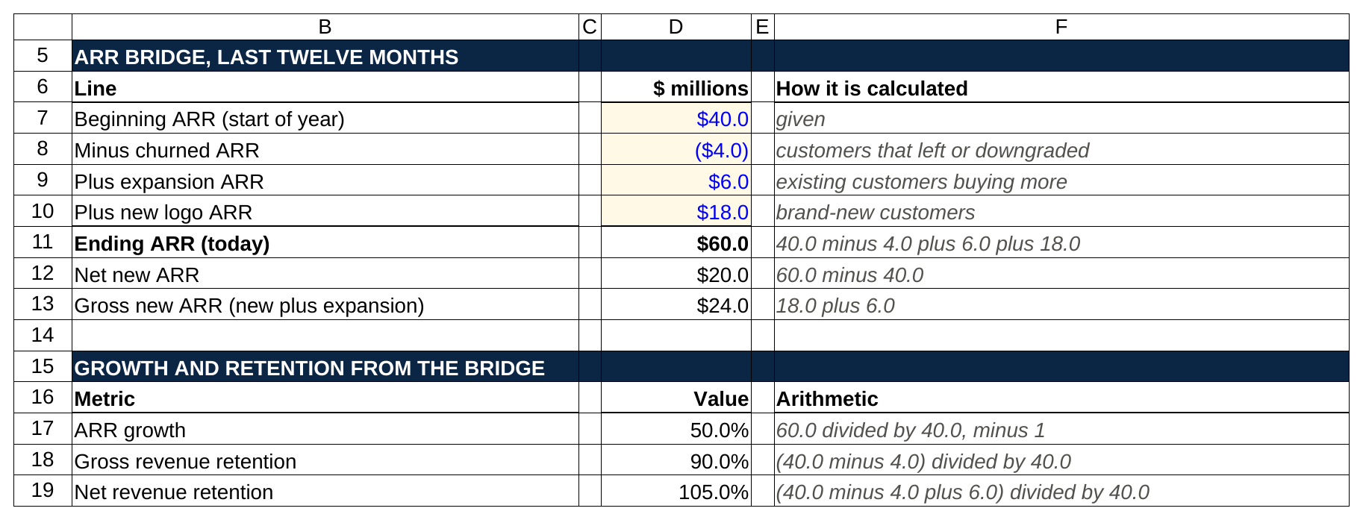
Ending ARR is a SUM of the four bridge lines, and each retention figure is a ratio of two of them, which is why the bridge is the first thing an investor asks for.

Gross revenue retention (GRR) is how much of last year's ARR is still here from the same customers, ignoring anything they added. Take the $40.0 million you started with, subtract the $4.0 million that churned, and divide by the $40.0 million: 90.0 percent. GRR can never be above 100 percent. It answers one question: do customers stay? For software sold to businesses, investors generally want to see 90 percent or better, and below the mid-80s is a pass for most growth funds [VERIFY: general benchmark; varies by firm and segment].

Net revenue retention (NRR) adds the expansion back. Start with $40.0 million, subtract $4.0 million of churn, add $6.0 million of expansion, and divide by $40.0 million: 105.0 percent. NRR above 100 percent means the existing customer base grows on its own even if the company signs nobody new. That's why it's the number public software investors quote first. Harborline's 105 percent is fine, not great; the best products run 120 percent or more because customers keep adding seats [VERIFY: benchmark].

Why both? Because they fail differently. A company with 80 percent GRR and 110 percent NRR is losing a fifth of its customers every year and covering it with big expansions from the ones that stay. That's fragile. A company with 95 percent GRR and 100 percent NRR keeps everyone and never upsells. That's a sales problem, which is fixable with money, which is what a growth investor brings. Interviewers ask for both to see whether you know the difference.

Now the cost side.

Input | Value
Revenue this year | $50.0
Gross margin | 76.0%
Gross profit | $38.0
Sales and marketing spend | $20.0
Net burn (cash out minus cash in) | $5.0
ARR per customer | $60,000
Customers today | 1,000
New customers signed this year | 300

Harborline's revenue this year is $50.0 million (ARR ramped from $40.0 to $60.0 million during the year, so the revenue earned sits in between). Gross margin is 76.0 percent: after hosting, customer support and implementation costs, the company keeps 76 cents of every dollar, so gross profit is $38.0 million. It spent $20.0 million on sales and marketing and burned $5.0 million of cash in total. Each customer pays about $60,000 a year, so $60.0 million of ARR is 1,000 customers, and $18.0 million of new logo ARR is 300 new customers.

Metric | Value | Arithmetic
CAC (cost to win one customer) | $66,667 | $20.0M divided by 300 new customers
CAC payback | 13.2 months | $20.0M divided by ($24.0M times 76%), times 12
LTV (lifetime gross profit per customer) | $456,000 | $60,000 times 76%, divided by 10% churn
LTV to CAC | 6.8x | $456,000 divided by $66,667
Magic number | 1.00x | $20.0M net new ARR divided by $20.0M S&M
Burn multiple | 0.25x | $5.0M net burn divided by $20.0M net new ARR
Free cash flow margin | (10.0%) | negative $5.0M divided by $50.0M
Rule of 40 score | 40 | 50.0% growth plus (10.0%) margin

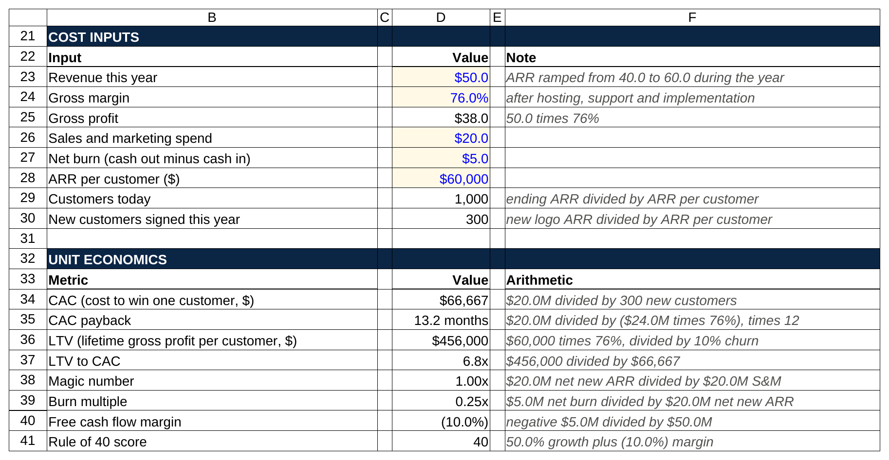
Every metric in the lower block is a formula on the inputs above it, so changing churn or sales spend, as the week 2 drill asks, moves all eight at once.

Gross margin first, because it feeds everything below it. Software usually runs 70 to 80 percent gross margins [VERIFY: benchmark]; a "software" company at 50 percent is often a services company with a software label, and the exit multiple will say so.

Customer acquisition cost (CAC) is what it costs to win one new customer. Divide the sales and marketing spend, $20.0 million, by the 300 new customers: $66,667 each. Simple version; a careful analyst would strip out the part of the spend aimed at existing customers, and you can say that.

CAC payback is how many months of gross profit from new business it takes to earn that spend back. Take the $24.0 million of gross new ARR, multiply by the 76 percent gross margin to get $18.24 million of annual gross profit from it, divide the $20.0 million of spend by that to get 1.10 years, and multiply by 12: 13.2 months. Under 12 months is excellent, 12 to 24 is normal for software sold to businesses, and over 24 means the company is buying growth it can't afford [VERIFY: benchmark].

Lifetime value (LTV) is the gross profit a customer produces before it leaves. A customer pays $60,000 a year, the company keeps 76 percent of it, so $45,600 of gross profit a year. Divide by the churn rate to get the expected lifetime: at 10 percent annual churn, the average customer lasts 10 years, so $456,000. LTV to CAC is $456,000 divided by $66,667: 6.8x. The rule of thumb is that 3x is healthy and under 1x means every new customer loses money over its life [VERIFY: benchmark]. Say out loud, when you use it, that LTV depends on a churn rate that can change, which is why investors trust payback more.

The magic number is net new ARR divided by sales and marketing spend. Harborline added $20.0 million of ARR on $20.0 million of spend: 1.0x. Above 1.0x says each dollar of selling produces at least a dollar of recurring revenue, and the usual reading is that a company above about 0.75x should spend more on sales, because the machine works [VERIFY: benchmark]. The strict version uses quarters: the quarter's increase in revenue, times four to put it on a yearly basis, divided by the previous quarter's sales and marketing spend. The annual version is fine for an interview if you say which one you're using.

The burn multiple is net cash burn divided by net new ARR: how many dollars the company burns to add a dollar of recurring revenue. Harborline burned $5.0 million to add $20.0 million: 0.25x. David Sacks of Craft Ventures published the metric and its bands in an April 2020 essay: under 1x is amazing, 1 to 1.5x great, 1.5 to 2x good, 2 to 3x suspect, above 3x bad [VERIFY: Sacks's "The Burn Multiple" essay and the exact bands]. The metric caught on because it is hard to game: a company can grow fast by spending wildly, and the burn multiple shows the bill.

The Rule of 40 is growth rate plus profit margin, with the target that they add to 40 or more. Harborline grew 50 percent and ran a free cash flow margin of negative 10 percent ($5.0 million of burn on $50.0 million of revenue): 50 minus 10 is 40, exactly on the line. The rule was popularized by the venture investor Brad Feld in a February 3, 2015 blog post titled "The Rule of 40% For a Healthy SaaS Company"; he wrote that he'd heard it from a late-stage investor at a board meeting, and his examples were the same arithmetic: growing 20 percent, make a 20 percent profit; growing 50 percent, you can lose 10 [VERIFY: feld.com, February 3, 2015]. The reason it stuck is that it lets you compare a fast-growing money-loser to a slow-growing cash machine on one scale.

Harborline scores well on every efficiency metric but one, net revenue retention, and that one gap is where an investor would spend the diligence. That's how you use the metrics in an interview: compute them, then say which one you'd chase.

8. Valuation: growth companies are priced on revenue, and growth explains the multiple
Interviewers ask three things here: why revenue and not EBITDA, what the multiple is, and why two companies with the same revenue trade at different multiples.

Growth companies are valued on revenue because there's no profit to value yet, and the profit that exists is a choice the company is making. A software business growing 50 percent spends ahead of its revenue on salespeople and engineers. Its EBITDA (earnings before interest, taxes, depreciation and amortization, the rough operating profit a buyout investor starts from; our EBITDA explainer covers it) is small or negative, and it could be positive next quarter if management stopped hiring. Pricing the company on a number management can flip at will tells you little. Pricing it on recurring revenue, with the margin and growth as adjustments, tells you more. So the number everyone quotes is enterprise value to ARR (or to next-twelve-months revenue for public companies).

Item | Value | Arithmetic or source
Harborline entry EV to ARR | 10.0x | 600.0 divided by 60.0
Harborline ARR growth | 50.0% | from the ARR bridge in section 7
Growth-adjusted multiple | 0.20x | 10.0 divided by 50
Public software median EV to NTM revenue | 4.0x | Clouded Judgement, Sep 11, 2026
Public high-growth bucket (over 22% growth) | 17.1x | same source
Public median NTM growth | 13% | same source
Public median growth-adjusted multiple | 0.31x | 4.0 divided by 13

The Harborline deal in section 11 is priced at a $600.0 million post-money valuation on $60.0 million of ARR: 10.0x. Is that expensive? Against the public market it looks rich. Jamin Ball's Clouded Judgement newsletter, which tracks public software companies, put the median at 4.0x next-twelve-months (NTM) revenue on September 11, 2026, with a median growth rate of 13 percent; the high-growth bucket, companies projected to grow faster than 22 percent, traded at 17.1x [VERIFY: Clouded Judgement, September 11, 2026 issue; these move weekly]. Harborline grows 50 percent. It belongs in the top bucket, where 10x is a discount.

The growth-adjusted multiple, the revenue multiple divided by the growth rate, is how an interviewer expects you to compare two companies with different growth. Divide Harborline's 10.0x by its 50 points of growth: 0.20x per point of growth. The public median, 4.0x on 13 percent growth, is 0.31x per point. On that measure Harborline is cheaper than the average public software company, because you're paying less for each point of growth. The number has limits (it treats a point of growth at 10 percent the same as a point at 100 percent, and ignores margin), but it's the quickest way to show you understand why the multiple and the growth rate can't be discussed separately.

The follow-up is always "what would change the multiple." Retention, because an ARR dollar that renews is worth more than one that doesn't. Gross margin, because a 60 percent margin dollar of revenue produces less profit than a 76 percent one. Growth durability, because a 50 percent grower that's about to hit a market ceiling deserves a lower multiple than one with room. And the exit: a company that a strategic buyer wants (a bigger software company that can sell Harborline's product to its own customers) can fetch a multiple the public market wouldn't pay. Say those four and you've answered it.

9. Deal terms, walked with numbers
Four terms come up in every growth equity interview: pre-money versus post-money, dilution, the cap table, and the liquidation preference. All four are arithmetic, and all four are in the Harborline deal.

Term | Value | Arithmetic
New money in | $100.0 | given
Post-money valuation | $600.0 | given (10.0x ending ARR)
Pre-money valuation | $500.0 | 600.0 minus 100.0
Ownership bought | 16.67% | 100.0 divided by 600.0
Entry EV to ARR | 10.0x | 600.0 divided by 60.0
Shares before the round | 50,000,000 | given
Price per share | $10.00 | $500.0M divided by 50,000,000
New shares issued | 10,000,000 | $100.0M divided by $10.00
Shares after the round | 60,000,000 | 50,000,000 plus 10,000,000

Pre-money is what the company is worth before the check; post-money is pre-money plus the check; and ownership is the check divided by post-money. The firm invests $100.0 million at a $600.0 million post-money. Pre-money is $600.0 minus $100.0, so $500.0 million. Ownership is $100.0 divided by $600.0: 16.67 percent. The trap in the question is which number the term sheet (the short document that sets out the deal's price and terms) names. "$100 million at a $500 million valuation" means pre-money, and the firm gets 100 divided by 600. "$100 million at a $600 million post" means the same deal. If someone says "$100 million at $500 million post," the firm gets 20 percent, and that's a different price. Always ask which.

The price per share makes dilution concrete. Harborline had 50,000,000 shares before the round (counting the employee option pool). Pre-money of $500.0 million divided by 50,000,000 shares is $10.00 a share. The firm's $100.0 million buys 10,000,000 new shares at $10.00. After the round there are 60,000,000 shares, and the firm's 10,000,000 is 16.67 percent of them.

Holder | Shares before | % before | Shares after | % after
Founders | 30,000,000 | 60.0% | 30,000,000 | 50.00%
Earlier venture investors | 15,000,000 | 30.0% | 15,000,000 | 25.00%
Employee option pool | 5,000,000 | 10.0% | 5,000,000 | 8.33%
New growth investor (Series C preferred) | 0 | 0.0% | 10,000,000 | 16.67%
Total | 50,000,000 | 100.0% | 60,000,000 | 100.00%

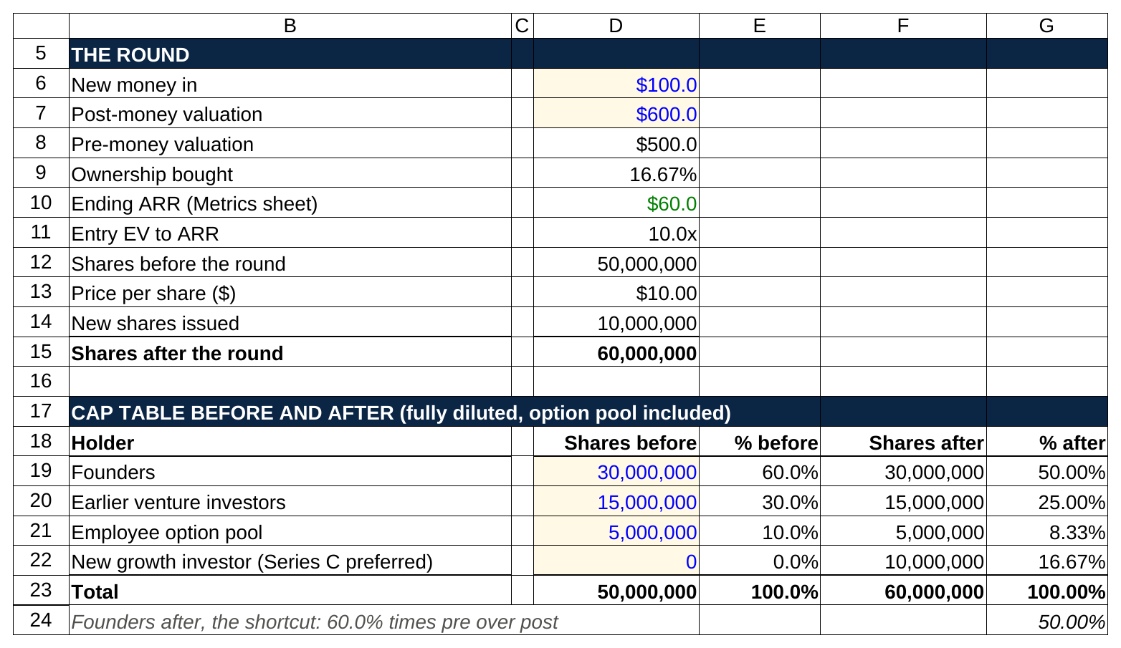
Price per share is pre-money over the old share count, and the founders' 60 percent becomes 50 percent without selling a share, the same answer as 60 percent times 500 over 600.

Dilution is what the new shares do to everyone else. The founders owned 30,000,000 of 50,000,000 shares, 60 percent. They still own 30,000,000 shares, but of 60,000,000 now, so 50.00 percent. The shortcut: multiply the old stake by pre-money over post-money, 60 percent times 500 over 600, which is 50 percent. The same haircut hits the earlier venture investors (30 percent to 25 percent) and the option pool (10 percent to 8.33 percent). Nobody sold anything; the pie got bigger. The founders' 50 percent of a $600.0 million company is $300.0 million, which is the whole point of agreeing to it.

Now the liquidation preference, which is the term that makes preferred stock preferred. The firm's shares carry a 1x non-participating liquidation preference. Three words, three ideas. "Liquidation preference" means that when the company is sold, the preferred holder is paid before the common holders. "1x" means the amount paid first is one times what was invested, $100.0 million. "Non-participating" means the firm has to choose: take the $100.0 million and stop, or convert to common and take its 16.67 percent of everything. It can't do both.

Scenario | Equity value | As common (no preference) | 1x preference amount | 1x non-participating payout | Which the investor picks | 1x participating payout
Bear | $270.0 | $45.0 | $100.0 | $100.0 | preference | $128.3
Base | $1,680.0 | $280.0 | $100.0 | $280.0 | convert to common | $363.3
Bull | $3,240.0 | $540.0 | $100.0 | $540.0 | convert to common | $623.3

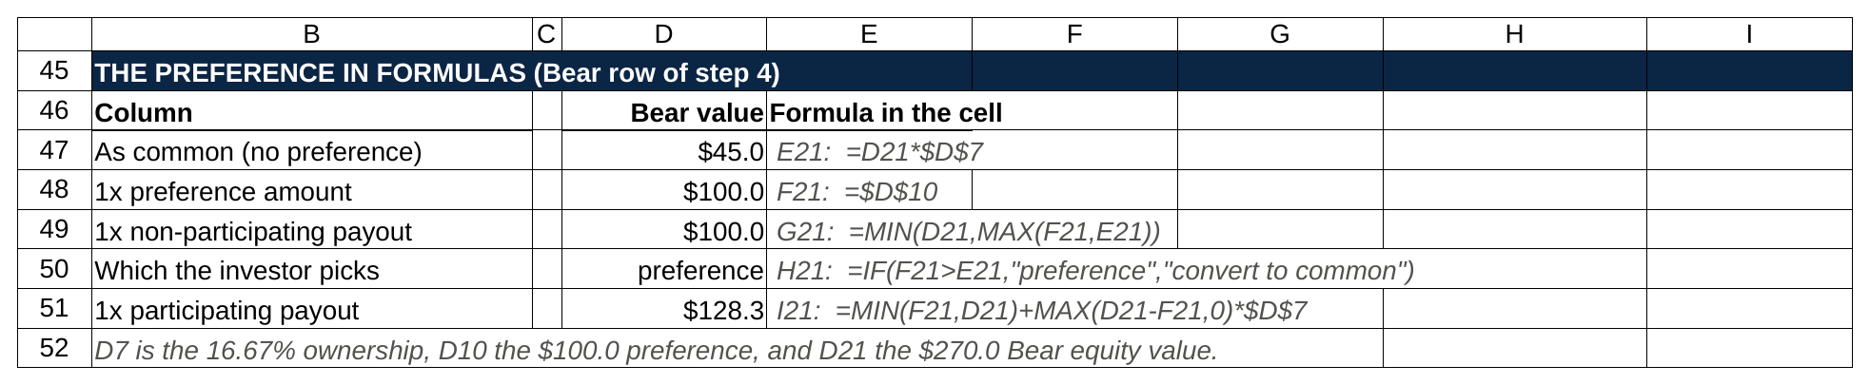
The non-participating payout is one line, the bigger of the preference and the as-converted share, capped at what the company sold for; participating adds the share on top of the preference.

A 1x non-participating preference changes nothing when the deal works and returns the firm's money when it doesn't, which is why a growth investor accepts a minority stake. Run the three exits from section 11. In the Bear case Harborline sells for $270.0 million. As a common holder the firm would get 16.67 percent of that, $45.0 million, and lose more than half its money. With the preference it takes $100.0 million instead and gets its capital back. In the Base case the sale is $1,680.0 million; 16.67 percent is $280.0 million, which is far above $100.0 million, so the firm converts and the preference never comes up. Same in the Bull case: $540.0 million as common beats $100.0 million. The preference only matters below the point where 16.67 percent of the sale equals $100.0 million, a $600.0 million exit, which is the entry price.

The participating version is the one founders fight. Participating preferred takes the $100.0 million first and then also takes its 16.67 percent of what's left, as if it had converted too. In the Bear case: $100.0 million, plus 16.67 percent of the remaining $170.0 million, $28.3 million, for $128.3 million. In the Base case: $100.0 million plus 16.67 percent of $1,580.0 million, which is $363.3 million against $280.0 million non-participating. That extra $83.3 million comes straight out of the founders' and employees' share. Most growth deals today are 1x non-participating [VERIFY: market practice; term surveys vary], and if an interviewer asks you which you'd push for, the honest answer is "non-participating is the market, and participating is what you ask for when you're worried about the downside and the founder has no other option."

What the common holders get is worth stating, because it answers "why would a founder agree to this." In the Base case, founders, earlier investors and employees split $1,400.0 million, 83.3 percent of the exit. In the Bear case they split $170.0 million, 63.0 percent. The preference cost them in the bad case and nothing in the good one. A founder who believes in the base case gives up little by granting it, and in exchange gets a higher valuation than an investor would pay for plain common stock, or gets the deal at all.

10. Judgment questions and behaviorals
"What would make you pass on a company growing 80 percent a year?" The question is checking whether you worship growth. You shouldn't.

"Seven things, roughly in the order I'd check them. Gross revenue retention under about 85 percent, because growth that leaks is expensive growth. Customer concentration: if one customer is more than 15 or 20 percent of revenue, the growth rate is one phone call from reversing. Gross margin under 60 percent, which usually means the product needs people to deliver it and won't scale like software. A burn multiple above 2x, because then the 80 percent is being bought. A market that caps out: if the company already has a third of the customers that could ever buy it, the 80 percent ends soon. Growth that's mostly price increases on existing customers rather than new ones, which works once. And the price: at some multiple the best company in the world is a bad investment, and I'd want to see what the 80 percent is costing us per point of growth."

Then, if there's time: "I'd also want to know why the founder is raising. Growth at 80 percent with low burn usually means they don't need money, so the money is for a secondary, an acquisition or a specific plan, and I'd want to hear the plan."

"Here's a company at $20 million of ARR growing 30 percent with 95 percent gross retention. Here's one at $20 million growing 70 percent with 80 percent gross retention. Which do you want?" There's no right answer, and the interviewer knows it. The first is the safer underwrite: durable revenue, slower compounding, probably a lower multiple at exit. The second could be the better company if the churn is from a customer segment it's deliberately leaving, or a worse one if the product doesn't stick. Say that, then say what single number you'd ask for to decide: retention by cohort (do customers signed two years ago still renew?) for the second company, and the sales efficiency (can it grow faster with more money?) for the first. The answer to a two-company question is the one number that would change your mind, not a pick.

"Tell me about a time you found something nobody asked you to find." This is the behavioral version of the sourcing question. The best answers are small and specific: the club treasurer who noticed a vendor was overcharging and found a cheaper one, the student who built a list of every alum at a firm before anyone suggested it, the summer intern who noticed a customer in the CRM hadn't been contacted in a year and called. Tell it in four sentences: what you noticed, what you did about it without being asked, what came of it, what you'd do differently.

"Tell me about being told no and what you did next." They want to see that no doesn't stop you and also that you don't become a pest. Rohan's answer, if you want a template: he emailed a founder twice with no reply, found the company's head of operations on LinkedIn, sent her a one-page comparison of three competitors' pricing, and got a call with the founder the following week. Then he stopped after that call, because the founder wasn't raising, and set a reminder for six months.

"How do you organize a week with no fixed schedule?" Growth equity analysts aren't staffed hour by hour the way bankers are. Say how you'd split it: outreach blocked in the morning when founders answer email, calls in the early afternoon, research and CRM notes late in the day, one market map a week on Fridays. Then say how you'd measure it: companies logged, founders reached, screens written. A candidate with a number for each is a candidate who'll survive the first month.

11. The worked investment screen: Harborline
Here's the full screen, the way a first-year analyst would build it in a modeling test, with every step shown. The company is fictional and the numbers are invented, but the arithmetic is the real thing. The screen ignores cash and debt at exit (so equity value equals enterprise value), ignores later funding rounds and option pool top-ups, and assumes a five-year hold with one check in and one check out. A real screen layers those in; the mechanics don't change.

Step 1: the company today. From section 7: $60.0 million of ARR, up from $40.0 million a year ago (50 percent growth), gross retention 90 percent, net retention 105 percent, gross margin 76 percent, CAC payback 13.2 months, burn multiple 0.25x, Rule of 40 exactly 40, $5.0 million of burn on $50.0 million of revenue.

Step 2: the deal. $100.0 million of new Series C preferred stock (Series C just means the third priced round of preferred shares) at a $600.0 million post-money valuation. Pre-money $500.0 million, ownership 16.67 percent, entry multiple 10.0x ARR, $10.00 a share, 10,000,000 new shares. The firm's preferred carries a 1x non-participating liquidation preference.

Step 3: three exits, five years out. The whole return rests on two assumptions: how big ARR gets, and what multiple a buyer pays for it then. The CAGR column is the compound annual growth rate, the single yearly growth rate that would carry ARR from $60.0 million to the year-5 figure if growth were the same every year.

Scenario | ARR in year 5 | ARR CAGR from $60.0M | Exit EV to ARR | Equity value at exit | Our 16.67% as common
Bear | $90.0 | 8.4% | 3.0x | $270.0 | $45.0
Base | $240.0 | 32.0% | 7.0x | $1,680.0 | $280.0
Bull | $360.0 | 43.1% | 9.0x | $3,240.0 | $540.0

Bear: growth collapses to 8.4 percent a year, ARR reaches only $90.0 million, and a buyer pays 3.0x for a slow-growing software company. Equity value $270.0 million. Base: growth averages 32.0 percent a year (it starts at 50 and slows every year, which is what growth does), ARR quadruples to $240.0 million, and a buyer pays 7.0x for a company still growing well above the public median. Equity value $1,680.0 million. Bull: growth holds near 43 percent, ARR reaches $360.0 million, and a strategic buyer pays 9.0x. Equity value $3,240.0 million.

The exit multiple is the assumption that does the most damage in a growth equity screen, and a good candidate says so before the interviewer asks. Harborline goes in at 10.0x. Even the Bull case assumes the multiple falls to 9.0x, and the Base case assumes 7.0x. A screen that assumes you'll sell at the multiple you bought at is a screen that assumes nothing goes wrong, and partners don't underwrite to that.

Step 4: what the preferred gets. Apply the preference from section 9.

Scenario | Equity value | As common (no preference) | 1x preference amount | 1x non-participating payout | Which the investor picks | 1x participating payout
Bear | $270.0 | $45.0 | $100.0 | $100.0 | preference | $128.3
Base | $1,680.0 | $280.0 | $100.0 | $280.0 | convert to common | $363.3
Bull | $3,240.0 | $540.0 | $100.0 | $540.0 | convert to common | $623.3

Step 5: MOIC and IRR. MOIC (multiple on invested capital) is money back divided by money in. IRR (internal rate of return) is the annual rate that turns the money in into the money back over the hold. With one check in and one check out five years apart, IRR is MOIC to the power of one fifth, minus one. That's the whole formula for this screen, and you should be able to do it on a calculator in the room.

Scenario | MOIC as common | IRR as common | MOIC with 1x non-participating | IRR with 1x non-participating | MOIC with 1x participating | IRR with 1x participating
Bear | 0.45x | (14.8%) | 1.00x | 0.0% | 1.28x | 5.1%
Base | 2.80x | 22.9% | 2.80x | 22.9% | 3.63x | 29.4%
Bull | 5.40x | 40.1% | 5.40x | 40.1% | 6.23x | 44.2%

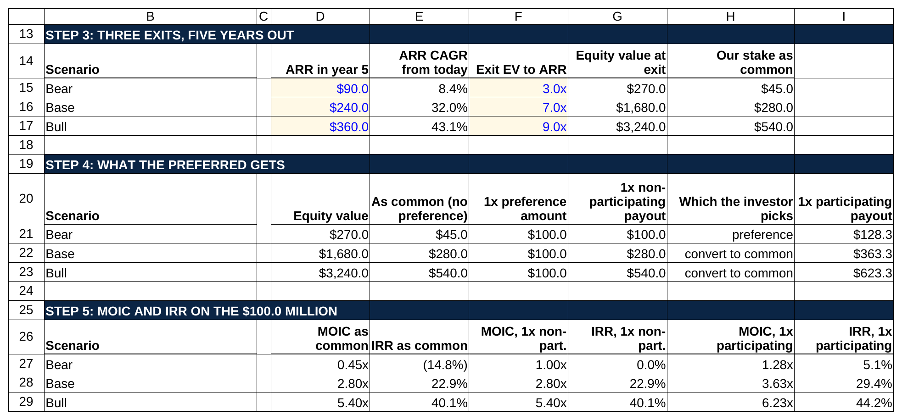
Only the blue inputs change between rows, ARR in year 5 and the exit multiple, and everything from equity value to the 22.9 percent Base case IRR follows from those two cells.

Walk the Base case out loud. Money back is $280.0 million on $100.0 million in, so MOIC is 2.80x. 2.80 to the power of one fifth is 1.2287; minus one is 22.9 percent. Check it the other way: $100.0 million growing at 22.9 percent a year for five years is $280.0 million. Bull: 5.40x, and 5.40 to the one fifth is 1.401, so a 40.1 percent IRR. Bear as common: 0.45x, and 0.45 to the one fifth is 0.852, so minus one gives a negative 14.8 percent a year. Bear with the preference: exactly 1.00x and a 0.0 percent IRR. The firm got its money back and earned nothing on it for five years, which is a loss in real terms, but it isn't a 55 percent loss.

A 1x preference turns a 0.45x outcome into a 1.00x outcome and leaves the 2.80x and 5.40x outcomes untouched, and that asymmetry is the entire reason the term exists. Look at the two MOIC columns side by side. Common and non-participating are identical in Base and Bull. They differ only in Bear, and there the preference adds $55.0 million. The participating column adds money in every case, which is why founders resist it: in the Base case it moves the firm from 2.80x to 3.63x, and that $83.3 million comes out of the common.

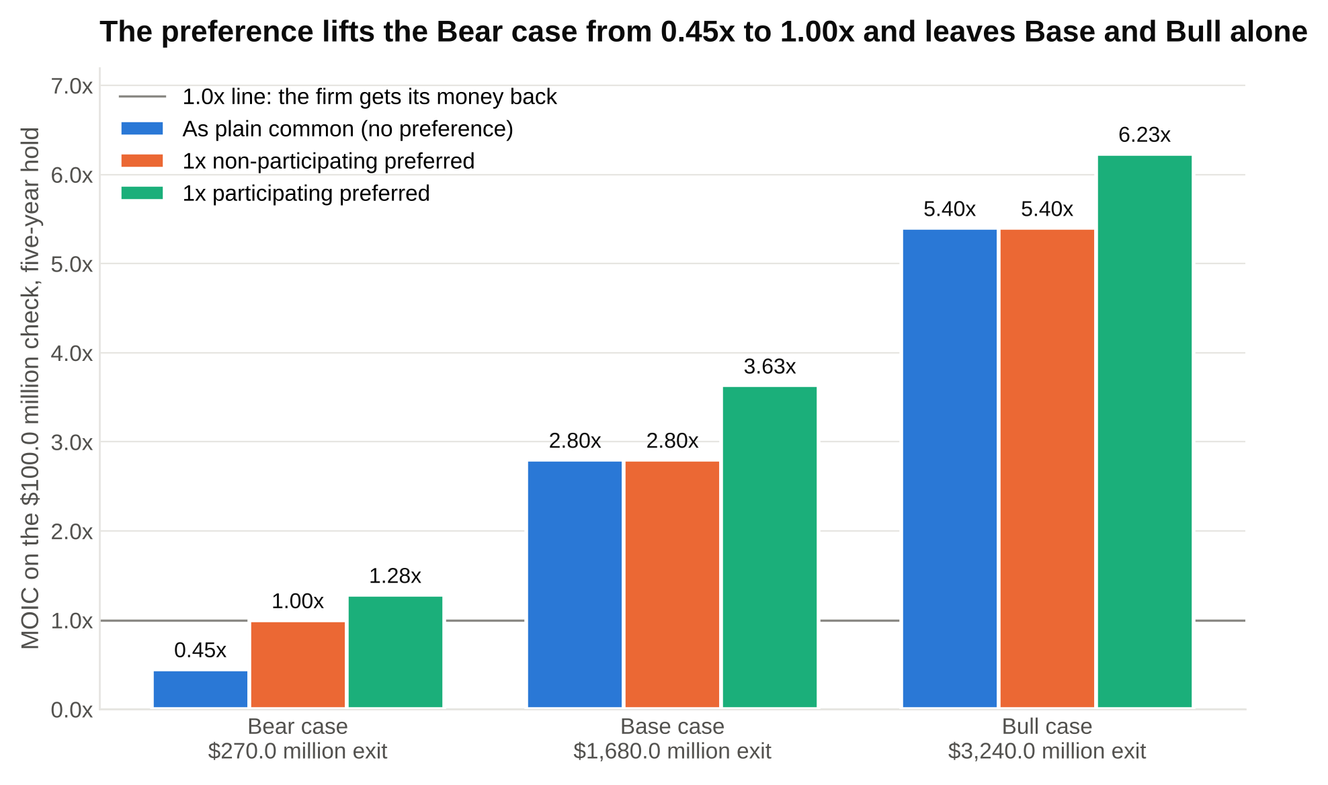
The orange bars match the blue ones in Base and Bull and only rise in Bear, while the green participating bars sit higher in every case, which is the $83.3 million founders fight over.

Scenario | Equity value | To preferred | To founders, VCs and employees | Their share
Bear | $270.0 | $100.0 | $170.0 | 63.0%
Base | $1,680.0 | $280.0 | $1,400.0 | 83.3%
Bull | $3,240.0 | $540.0 | $2,700.0 | 83.3%

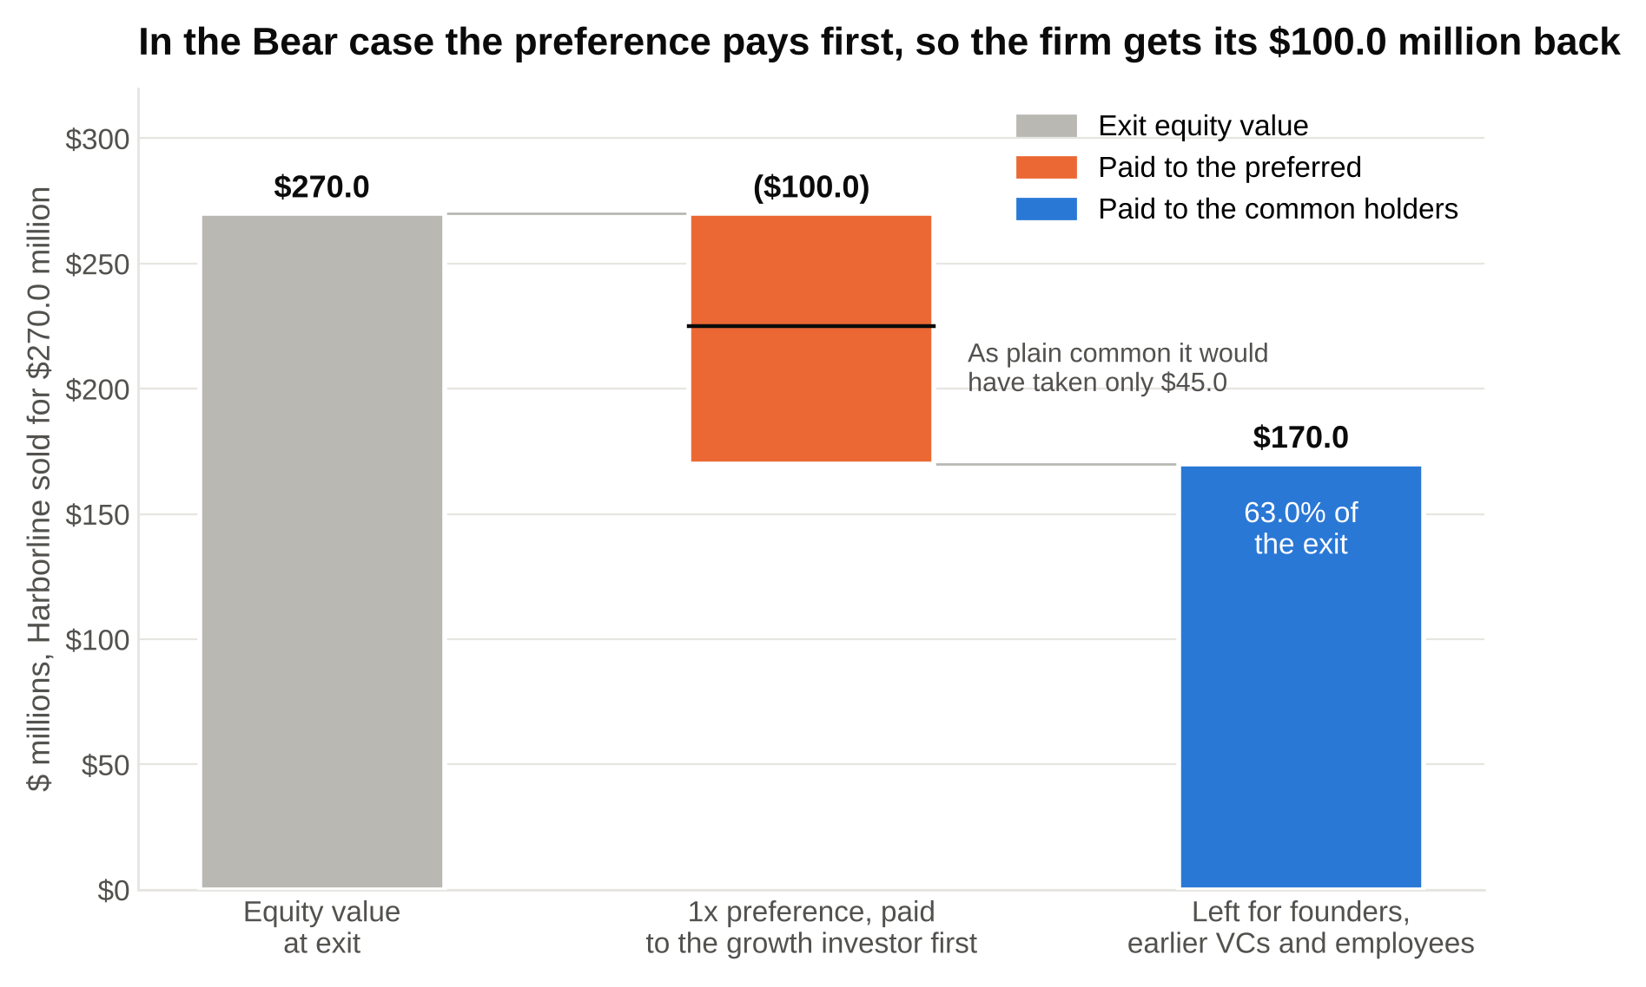
At a $270.0 million sale the preference takes $100.0 million off the top instead of the $45.0 million the firm's 16.67 percent would have earned, and the common holders split the $170.0 million left.

Step 6: the verdict. Would the firm do this deal? The Base case returns 2.80x and 22.9 percent, which is around but a little below the 3x and 25 percent most growth funds underwrite to [VERIFY: typical targets; firm-specific]. The Bear case returns capital. The Bull case is the kind of outcome that carries a whole fund's returns. The honest first-year answer is "close, and it depends on two things I'd want to diligence before I believed the Base case: whether net retention can get from 105 toward 115 percent, because that alone lifts the year-5 ARR, and whether 7.0x is a reasonable exit multiple for a company whose growth has slowed by year five." Then, if pushed on price: "At a $500.0 million post instead of $600.0, ownership would be 20 percent and the Base case would return $336.0 million, 3.36x. So the price is the negotiation."

That is the whole screen. Six steps, four tables, and the preference applied correctly. If you can do this in an hour from a blank sheet, you can pass the modeling round at every firm in section 2.

12. The sourcing drill you can run this week
Reading about sourcing is like reading about swimming. Do this instead, this week, and you'll have the material for every sourcing question in the process.

Day 1: pick a vertical you have a reason to know. Something your family's business uses, something from a summer job, something you've been a customer of. Narrow it until it's specific: not "healthcare software" but "scheduling software for independent dental practices." If you can't name three companies in it off the top of your head, it's probably specific enough.

Days 2 and 3: build the list. Thirty companies in a spreadsheet with these columns: name, what it sells, who buys it, headquarters, founded year, estimated headcount (LinkedIn), headcount a year ago if the tool you're using shows it, open sales roles, funding history (PitchBook if your school has it; otherwise the company's own press page), founder-owned or not, and one line on why it's interesting. Sources, in order: software review sites, trade show exhibitor lists, LinkedIn company search, PitchBook, and the customer logos on the websites of the first five companies you find (their competitors are listed there too, in effect).

Day 4: rank them. Sort by what you can see: headcount growth first, then open sales roles, then founder-owned. Pick the top five. Write a one-page first-screen note on each, in the structure from section 6: what it does, who buys, why now, what you can see, what you'd want to learn, what would make you pass.

Day 5: write the email and send it to the five founders. Here is the one that gets answered.

Subject: [Company] and the independent dental market
Hi [First name],
I'm a junior at [school] and I've spent the past month mapping scheduling software for independent dental practices. [Company] came up repeatedly: your customers mention [specific feature] in reviews, and you've added about a dozen people in the last year, which puts you among the fastest-growing names on my list of thirty.
I'm not selling anything and I'm not with a fund. I'd like fifteen minutes to learn how you think about the market, and I'll send you my map of the thirty companies in return, whatever you decide.
Would next Tuesday or Wednesday afternoon work?
[Name]

Why it works: it's specific (a feature, a headcount number, a list size), it offers something before it asks, it tells the truth about who you are, and it asks for a time. Founders get dozens of "I'd love to pick your brain" emails and almost none that have done the work.

One founder call, written up in a page, is worth more in a growth equity interview than any modeling certificate. Log every send, reply and call in your spreadsheet with a date and a next step. That spreadsheet is what you bring to the sourcing round. "Here's the list, here's who replied, here's what I learned" is an answer no prepared candidate can fake.

13. The four-week prep plan
Week 1: the vertical and the list. Run the drill in section 12 end to end. Read the "what we invest in" page of every firm in section 2 and write one line on each: check size, stage, sectors. Pick your three target firms.

Week 2: the metrics. Build Harborline's bridge and unit economics in a blank spreadsheet from the inputs in section 7 until the outputs match the tables. Then change the inputs (churn to $8.0 million, S&M to $30.0 million) and watch which metrics move. Learn to explain each metric from zero in two sentences, the way section 7 does, out loud.

Week 3: the deal math and the screen. Build the cap table and the three-scenario returns from sections 9 and 11, with the preference applied by formula (the maximum of the preference and the as-converted value). Time yourself building it from a blank sheet; under an hour is the goal. Write your "why growth equity" answers from section 5 and say them to someone who will interrupt you.

Week 4: the mocks. Two full mock processes with a friend: phone screen, sourcing round, case on a real company's public deck or press, final. Reach three current analysts at your target firms with a short, specific note (section 12's email, pointed at a person rather than a founder) and ask one question each about the weekly sourcing target. Send your applications with the list from week 1 mentioned in the cover note.

Four weeks is enough if the first week is the list, because every later round builds on it. Candidates who start with the model and leave sourcing for the end arrive at the interview with a spreadsheet and no companies, which is the candidate in the first paragraph of this article.

14. Say this, don't say that in a growth equity interview
Why growth equity?
Don't say: "I want to work with exciting high-growth companies and be closer to the business."
Say: "The analyst in growth equity decides every week which company deserves the firm's time, and I've spent a month doing that on my own in [vertical]. I'd rather start there than start on a debt schedule."

Pitch me a company.
Don't say: "I think [famous late-stage startup] is really interesting because everyone uses it."
Say: "[Company] sells [product] to [buyer]. It's founder-owned, about 150 people and up roughly 50 percent in a year on LinkedIn, and it's in a vertical where you've already backed two companies. The two things I'd want first are gross retention and customer concentration, and below 85 percent or above 20 percent I'd pass."

What would make you pass on a company growing 80 percent?
Don't say: "Nothing, that's an amazing growth rate."
Say: "Retention under 85, concentration over 20 percent, gross margin under 60, a burn multiple over 2x, or a market it's already a third of the way through. Growth that leaks or that's bought isn't growth."

What's net revenue retention?
Don't say: "It's a measure of how well a company retains revenue."
Say: "Last year's customers' ARR today, including what they added, divided by their ARR a year ago. Harborline's is 105 percent: $40 million minus $4 million of churn plus $6 million of expansion, over $40 million."

How does a liquidation preference work?
Don't say: "It protects the investor's downside."
Say: "At exit, the preferred gets the greater of its money back or its as-converted share. On a $100 million check at 16.7 percent, the preference matters below a $600 million exit and does nothing above it."

Why not banking?
Don't say: "I don't want to work the hours."
Say: "I'd learn the model in banking, and I'll learn it here too. What I won't learn in banking is how to find a company nobody has called. I've already started, and I'd rather be judged on that."

The founder won't take the call.
Don't say: "I'd keep following up until they responded."
Say: "I'd go to the CFO or head of sales, get a warm intro through a portfolio CEO or a customer, send a market map with no ask, and set a six-week reminder. Three nos means stop for a while."

Most of the reader questions I get about growth equity are versions of "am I technical enough." The answer is almost always yes. The question to ask instead is whether you've found anything. If you have a list of thirty companies in a vertical you understand, five founders you've written to, and one page on each of the three you'd want the firm to look at, you're ahead of nearly everyone in the process, including the candidates with the banking offers. Build the list this week. The interview starts there.

